Article
On
Temperature Prediction Model
using Python

Problem Statement
To predict the next-day maximum and minimum temperature with the help of past data provided. The data provided is of summer from 2013 to 2017. The input data is largely composed of the LDAPS model's next-day forecast data, in-situ maximum and minimum temperatures of present-day and geographic auxiliary variables. There are two outputs (i.e. next-day maximum and minimum air temperatures) in this data.
Information about the attributes present in the data set:
1. station - used weather station number: 1 to 25
2. Date - Present day: yyyy-mm-dd ('2013-06-30' to '2017-08-30')
3. Present_Tmax - Maximum air temperature between 0 and 21 h on the present day (Â°C): 20 to 37.6
4. Present_Tmin - Minimum air temperature between 0 and 21 h on the present day (Â°C): 11.3 to 29.9
5. LDAPS_RHmin - LDAPS model forecast of next-day minimum relative humidity (%): 19.8 to 98.5
6. LDAPS_RHmax - LDAPS model forecast of next-day maximum relative humidity (%): 58.9 to 100
7. LDAPS_Tmax_lapse - LDAPS model forecast of next-day maximum air temperature applied lapse rate (Â°C): 17.6 to 38.5
8. LDAPS_Tmin_lapse - LDAPS model forecast of next-day minimum air temperature applied lapse rate (Â°C): 14.3 to 29.6
9. LDAPS_WS - LDAPS model forecast of next-day average wind speed (m/s): 2.9 to 21.9
10. LDAPS_LH - LDAPS model forecast of next-day average latent heat flux (W/m2): -13.6 to 213.4
11. LDAPS_CC1 - LDAPS model forecast of next-day 1st 6-hour split average cloud cover (0-5 h) (%): 0 to 0.97
12. LDAPS_CC2 - LDAPS model forecast of next-day 2nd 6-hour split average cloud cover (6-11 h) (%): 0 to 0.97
13. LDAPS_CC3 - LDAPS model forecast of next-day 3rd 6-hour split average cloud cover (12-17 h) (%): 0 to 0.98
14. LDAPS_CC4 - LDAPS model forecast of next-day 4th 6-hour split average cloud cover (18-23 h) (%): 0 to 0.97
15. LDAPS_PPT1 - LDAPS model forecast of next-day 1st 6-hour split average precipitation (0-5 h) (%): 0 to 23.7
16. LDAPS_PPT2 - LDAPS model forecast of next-day 2nd 6-hour split average precipitation (6-11 h) (%): 0 to 21.6
17. LDAPS_PPT3 - LDAPS model forecast of next-day 3rd 6-hour split average precipitation (12-17 h) (%): 0 to 15.8
18. LDAPS_PPT4 - LDAPS model forecast of next-day 4th 6-hour split average precipitation (18-23 h) (%): 0 to 16.7
19. lat - Latitude (Â°): 37.456 to 37.645
20. lon - Longitude (Â°): 126.826 to 127.135
21. DEM - Elevation (m): 12.4 to 212.3
22. Slope - Slope (Â°): 0.1 to 5.2
23. Solar radiation - Daily incoming solar radiation (wh/m2): 4329.5 to 5992.9
24. Next_Tmax - The next-day maximum air temperature (Â°C): 17.4 to 38.9
25. Next_Tmin - The next-day minimum air temperature (Â°C): 11.3 to 29.8T
Please note that there are two target variables here:
1) Next_Tmax: Next day maximum temperature
2) Next_Tmin: Next day minimum temperature

Exploratory Data Analysis (EDA) with Remarks
First of all import the different libraries required to explore the basic information about the data-set. After importing the libraries, read the data set into pandas data frame. Then after analyzing it is known that the data set contains total ‘7752’ number of rows and 25 columns including the predictor variables.
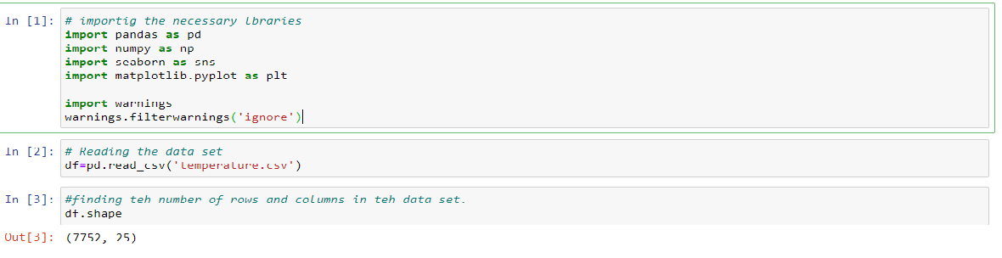
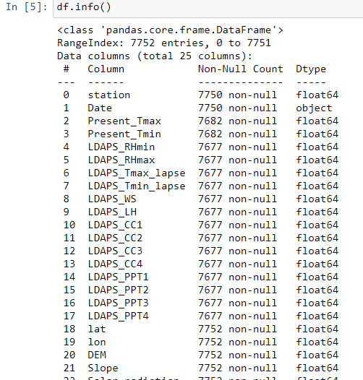

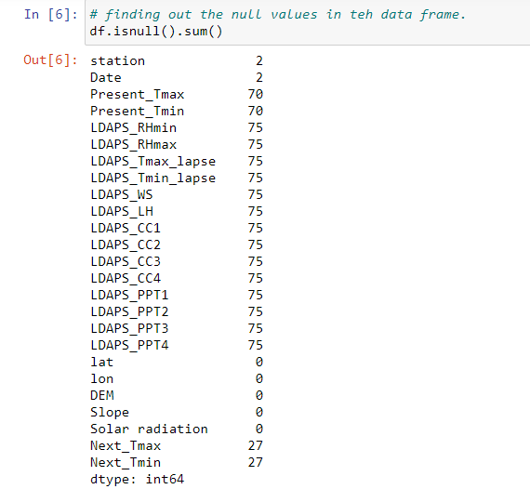

All the features in the data set are of numerical in nature except ‘date’ feature which is in string (object) format. There are null values present in the data set, hence dropped them. After dropping the null values the remaining number of rows are ‘7588’, means total number of 164 rows have been removed.
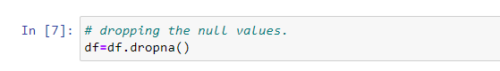
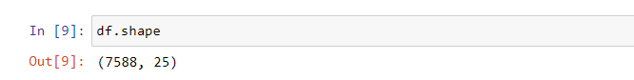
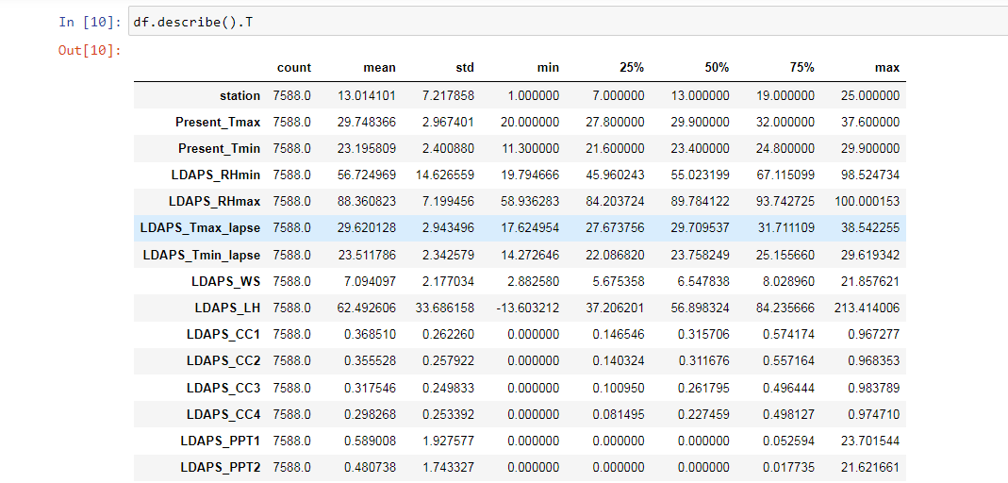
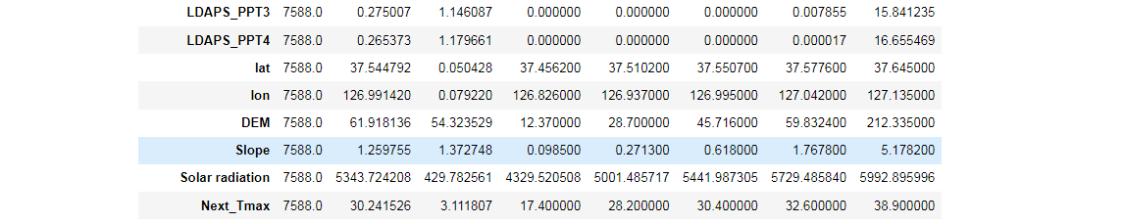
In this data set the median is less the mean in LDAPS_LH hence skewness might be present. There might be outliers in PPT1 to PPT4 because there is a huge difference between 75% value (3rd Quartile) and the max value present in the variable. Same is the case with ‘DEM & Slope’ variables. In the variable ‘Solar Radiation’ the mean is less than the median hence skewness might be present.
Now checking the relationship between different variables with ‘Date’ variable with the help of Line plots.
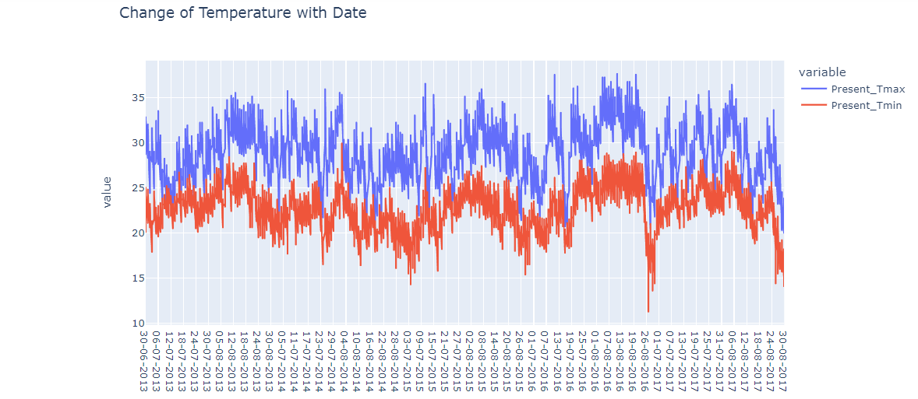
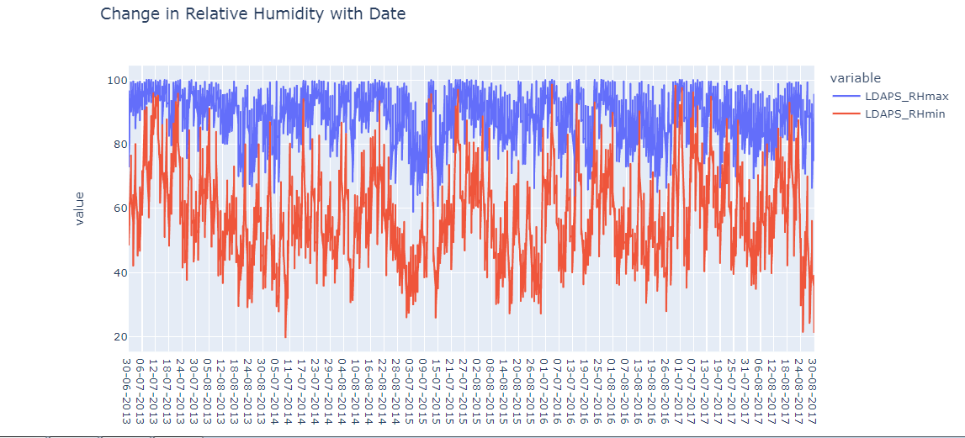

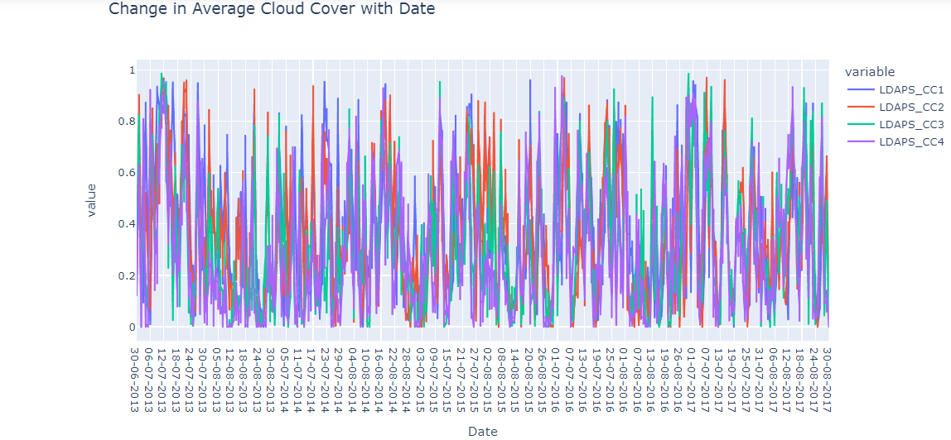
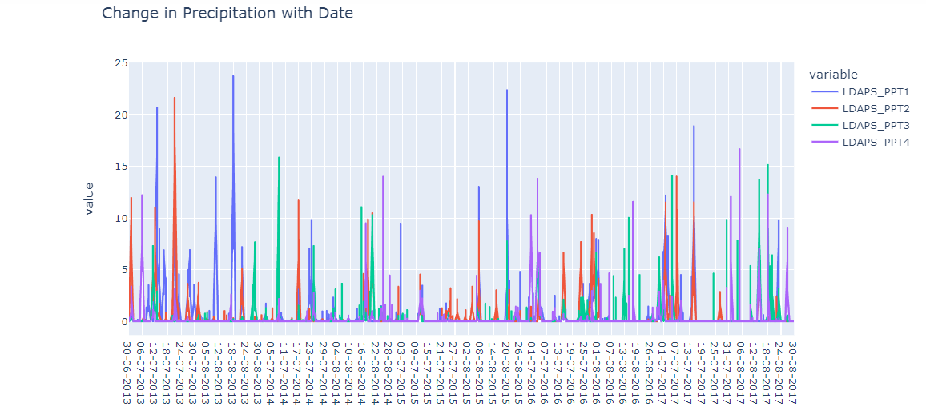
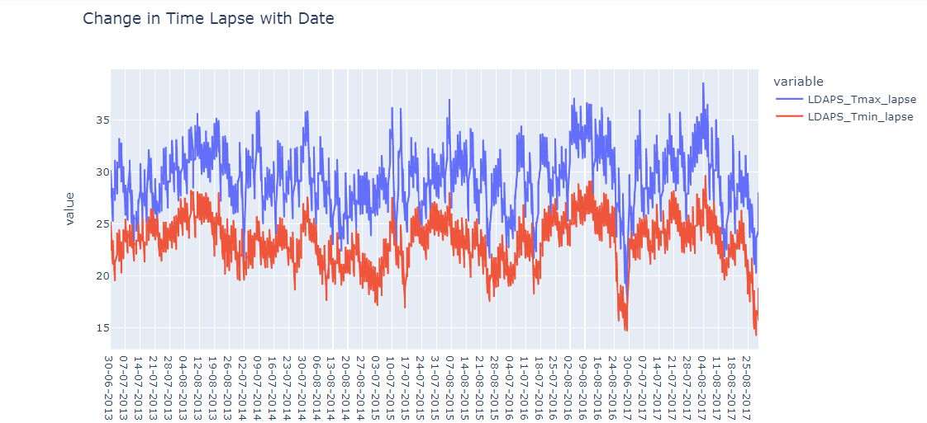
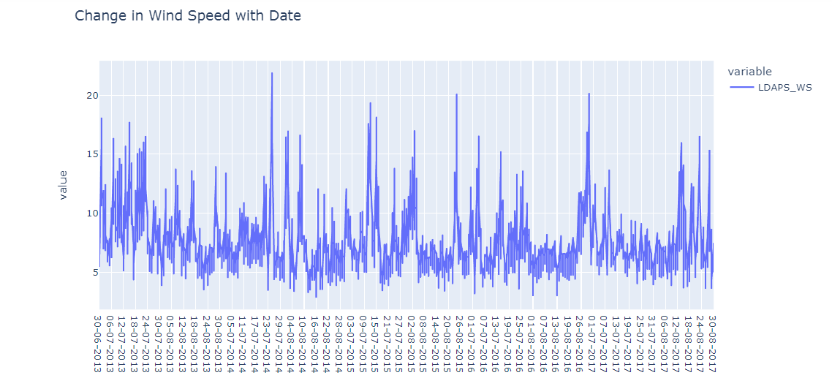
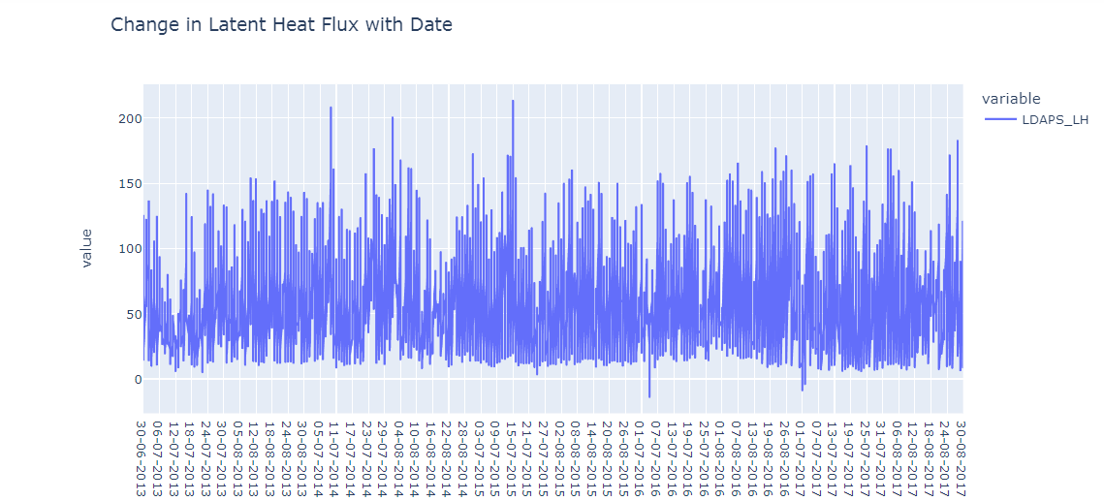
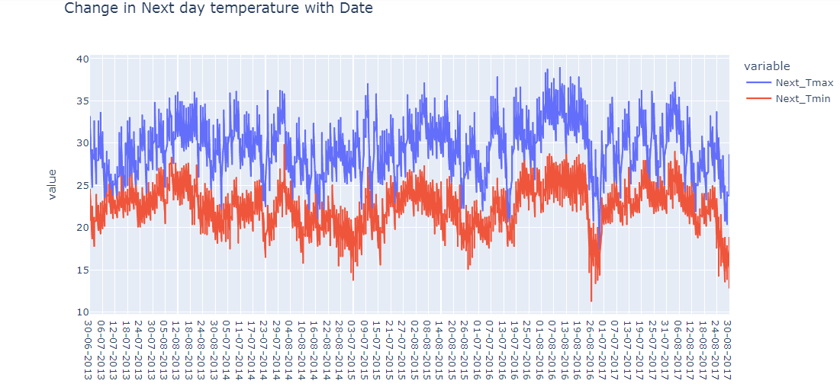
After plotting line plots between different variables with Date it is known that:
- The date on which the max temp value is less the min temp value is also less as compared to other dates.
- Approximately when the max relative humidity values are higher the min relative humidity values are also higher or vice-versa.
- Cloud coverage is almost following the same pattern as one split values are higher than rest of all the splits follow the same path.
- Precipitation values are different according to the split on many dates.
- There are few dates where the wind speed is exceptionally high.
- There are few exceptional high and lows on few dates regarding Latent Heat Flux.
Now checking whether there are outliers present in the data set with the help of Box Plots.
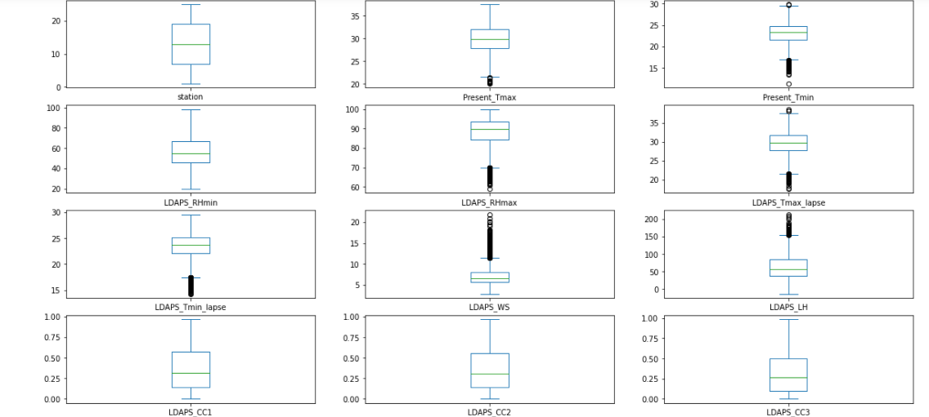
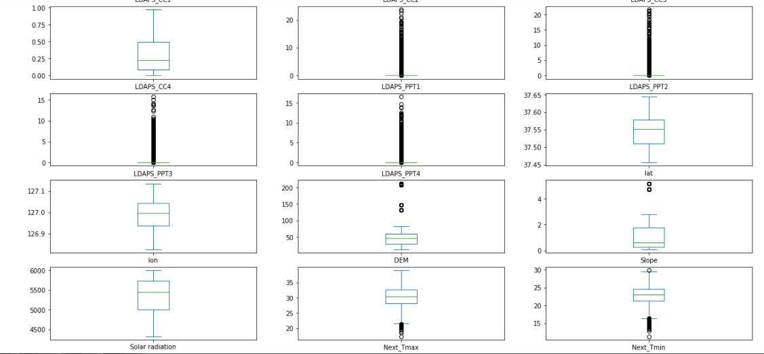

Now after using box-plots for checking the outlier’s presence it is known that there are outliers present in many variables, but we are not going to remove them as the outliers per variables are bulk in numbers, it might be because of the reason that the data under those variables follows this kind of pattern.
Then trying to find out the relationship of ‘Present T_Max and Present T_Min’ with the help of Join Plots.
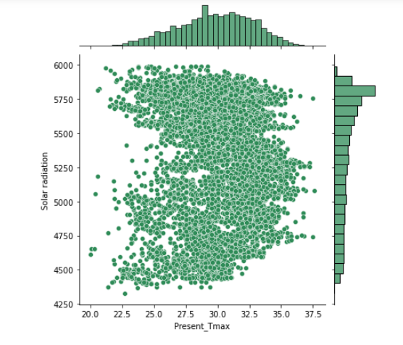
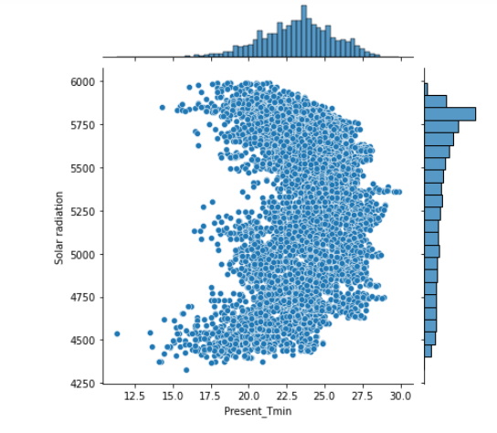
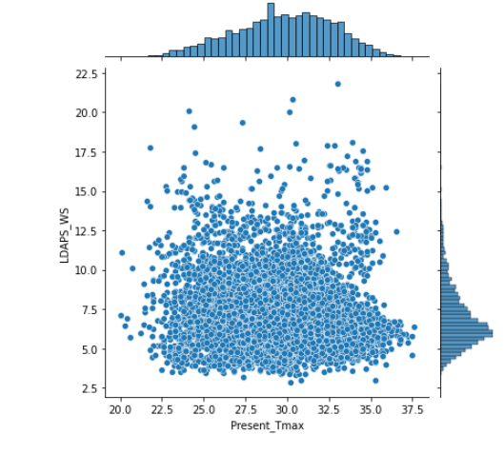
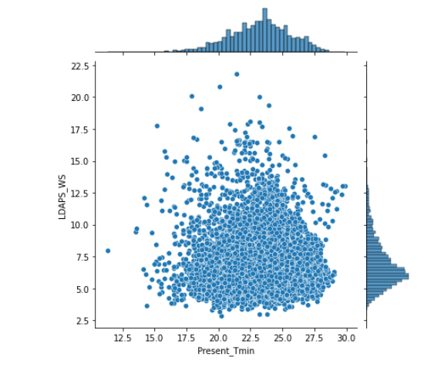
With the help of Joint Plots it is found that the:
- The higher values of solar radiation are related with lower temperatures
- The lower values of solar radiation are related with higher temperatures
- The lower values of wind speed are associated with higher temperature
- The higher values of wind are associated with lower temperature.
Now finding out the correlation between the different variables with the help of ‘heat-map’ .
It is found that there is a strong correlation is present among the variables.
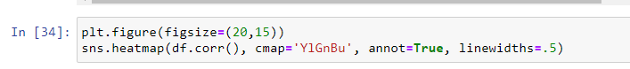
Data Pre-processing
- Separating the feature and the target variables
As there are two target variables ‘Next_Tmax & Next_Tmin’, so they are separated individually.
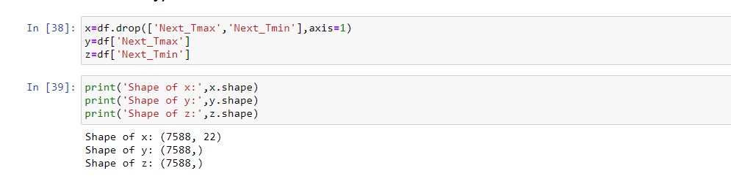
- Scaling the data or Normalizing the data
Feature scaling is a method used to normalize the range of independent variables or features of data. In data processing, it is also known as data normalization.
In this problem the Standard Scalar technique is used to scale or normalize the data set.
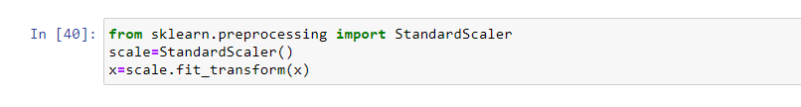
- Splitting the data set into train and testing part.
Separating data into training and testing sets is an important part of evaluating data mining models. Typically, when the data is separated into a training set and testing set, most of the data is used for training, and a smaller portion of the data is used for testing. Analysis Services randomly samples the data to help ensure that the testing and training sets are similar. By using similar data for training and testing, the effects of data discrepancies can be minimized and better understanding of the characteristics of the model can be achieved.
The data-set under this problem is divided into the ratio of 70:30 means 70% of the data set is under training and 30% of the data set is for testing purpose. Hence the training set contains ‘5311’ number of rows and testing data-set contains ‘2277’ number of rows.
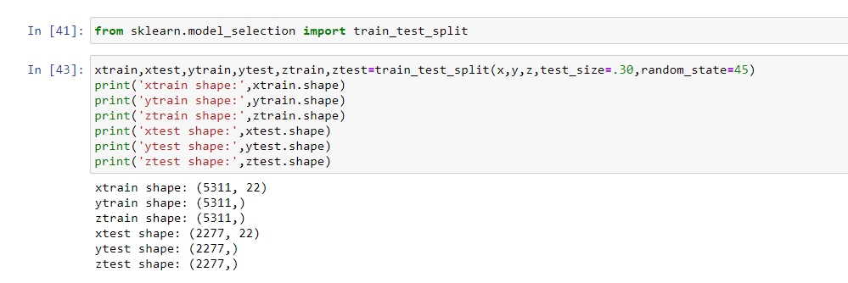
Model Building
Importing the different libraries for fitting model to the data set.

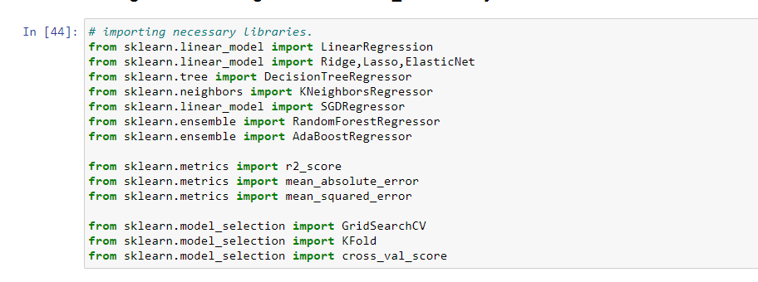
Part A: Building the predictive model for maximum temperature i.e ‘Next_Tmax’.
Fitting the regression models as:
- Linear Regression: Linear regression attempts to model the relationship between two variables by fitting a linear equation to observed data. One variable is considered to be an explanatory variable, and the other is considered to be a dependent variable.
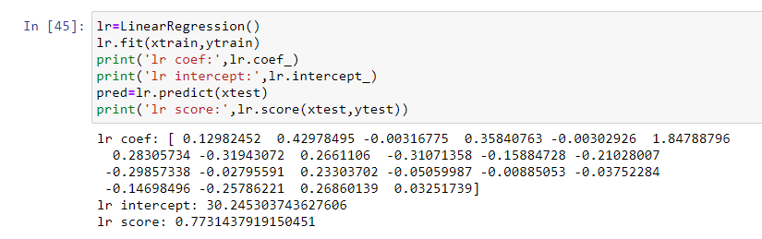
The value of linear regression score comes out to be 77.31%.
- Ridge, Lasso and ElasticNet: Lasso will eliminate many features, and reduce over-fitting in the linear model. Ridge will reduce the impact of features that are not important in predicting the y values. Elastic Net combines feature elimination from Lasso and feature coefficient reduction from the Ridge model to improve the model's predictions.
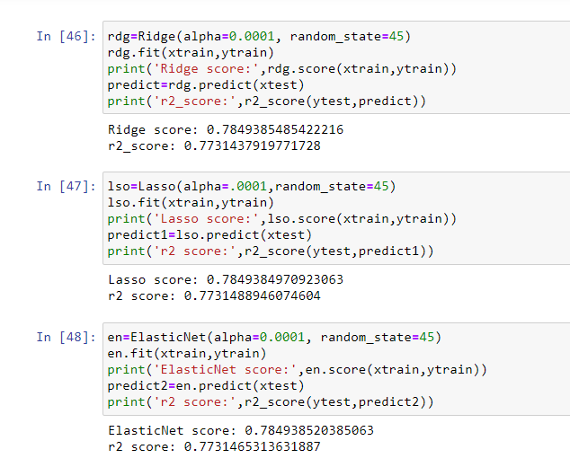
The R² value of all the three are same as the linear regression =77.31%
- Decision Tree Regressor: Decision tree builds regression or classification models in the form of a tree structure. It breaks down a dataset into smaller and smaller subsets while at the same time an associated decision tree is incrementally developed. The final result is a tree with decision nodes and leaf nodes. A decision node has two or more branches, each representing values for the attribute tested. Leaf node represents a decision on the numerical target. The topmost decision node in a tree which corresponds to the best predictor called root node. Decision trees can handle both categorical and numerical data.
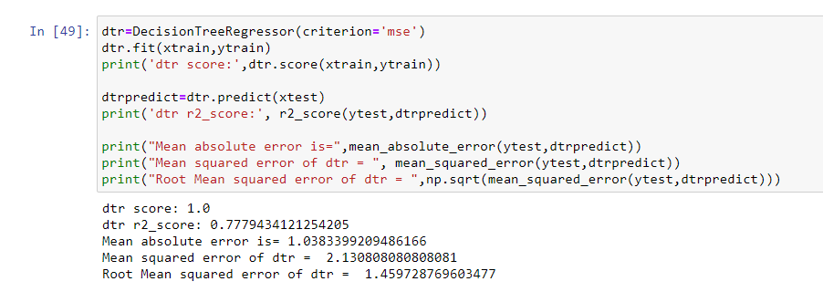
The r2 value of decision tree comes out to be 77.79 % and RMSE is 1.45 which is not a very good score hence trying with other models.
- Kneighbors Regressor: The KNN algorithm uses ‘feature similarity’ to predict the values of any new data points. This means that the new point is assigned a value based on how closely it resembles the points in the training set.
The first step is to calculate the distance between the new point and each training point. There are various methods for calculating this distance, of which the most commonly known methods are – Euclidian, Manhattan (for continuous) and Hamming distance (for categorical).
Euclidean Distance: Euclidean distance is calculated as the square root of the sum of the squared differences between a new point (x) and an existing point (y).
Manhattan Distance: This is the distance between real vectors using the sum of their absolute difference.
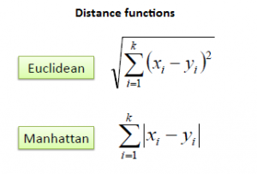
Hamming Distance: It is used for categorical variables. If the value (x) and the value (y) are the same, the distance D will be equal to 0. Otherwise D=1.
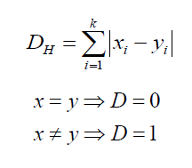
Once the distance of a new observation from the points in the training set has been measured, the next step is to pick the closest points. The number of points to be considered is defined by the value of k.
The second step is to select the k value. This determines the number of neighbors we look at when we assign a value to any new observation. For this purpose three values of K are being used as ‘k=5,10,3.
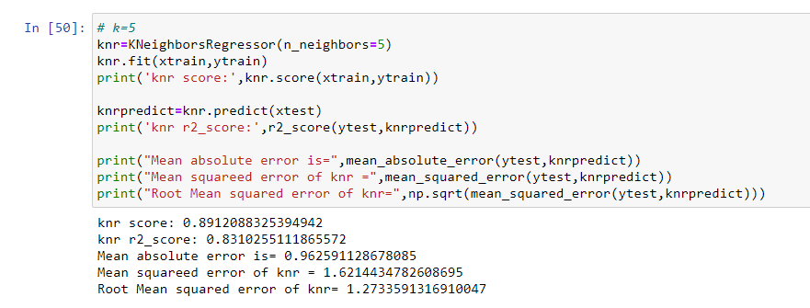
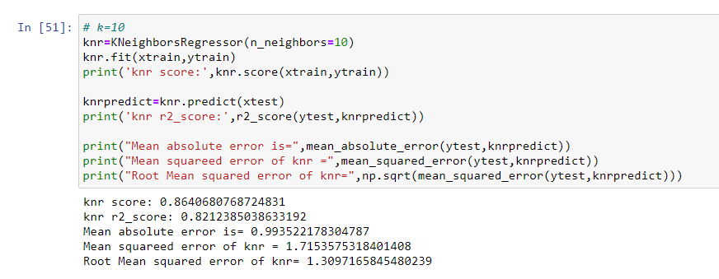
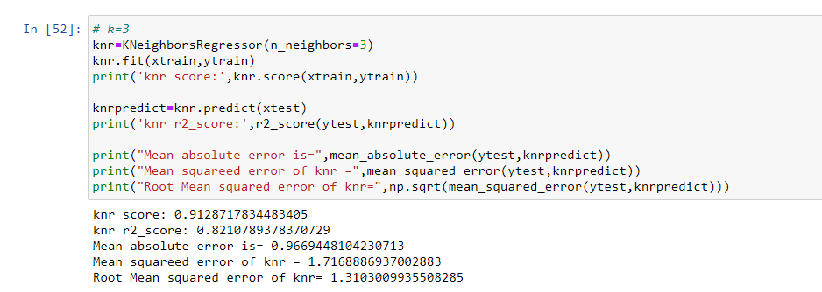
From all the above Model Fitting by KNeighbors Regressor, the R2 score with K=5 is the best one that is 83.10% with RMSE Score as 1.27. Hence it can be concluded that 5 nearest neighbors is giving the best scores as increasing or decreasing the values of K is reducing the scores and the RMSE values are also increasing.
- SGD Regressor: The class SGDRegressor(Stochastic Gradient Regressor) implements a plain stochastic gradient descent learning routine which supports different loss functions and penalties to fit linear regression models. In stochastic gradient descent, we repeatedly run through the training set one data point at a time and update the parameters according to the gradient of the error with respect to each individual data point. In other words, gradient descent uses an iterative approach, starting with random values of coefficients and intercept and slowly improving them using derivatives. The loss parameter of SGDRegressor provides the opportunity to change the loss function being used. The default is set to squared_loss which refers to the ordinary least squares fit. The SGDRegressor also provides a penalty parameter which basically acts as a regularization term and its default value is l2 that is Ridge Regression. It can also be set to l1 or elastic-net.
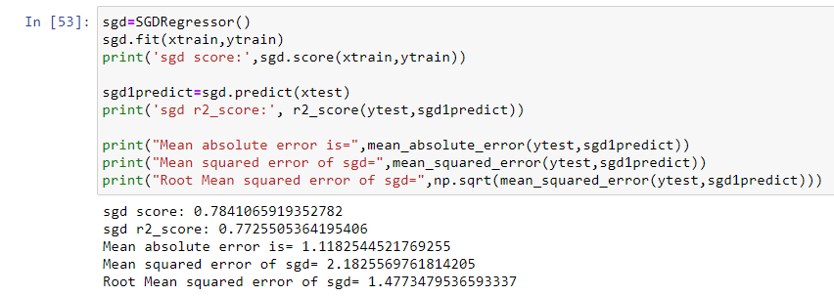
From the scores of SGDRegressor(Stochastic Gradient Descent Regressor), the R2 score is coming out to be 77.25 % which is quite low and the RMSE value of 1.477 which is quite high, hence this model is not working good. This might be because this regressor is based on linear regression principles and Linear Regressor is also not giving the satisfactory scores.
Ensemble Techniques
Ensemble learning is a general Meta approach to machine learning that seeks better predictive performance by combining the predictions from multiple models.
The three main classes of ensemble learning methods are bagging, stacking, and boosting:
- Bagging involves fitting many decision trees on different samples of the same dataset and averaging the predictions.
- Stacking involves fitting many different models types on the same data and using another model to learn how to best combine the predictions.
- Boosting involves adding ensemble members sequentially that correct the predictions made by prior models and outputs a weighted average of the predictions.
One bagging and one boosting technique is used to improve upon the score to find the best fir model.
Under Bagging technique ‘Random Forest Regressor’ and in Boosting technique ‘AdaBoost Regressor’ is being used.
- Random Forest Regressor: The random forest regression algorithm takes advantage of the ‘wisdom of the crowds’. It takes multiple (but different) regression decision trees and makes them ‘vote’. Each tree needs to predict the expected value based on the decision criteria it picked. Random forest regression then calculates the average of all of the predictions to generate a great estimate of what the expected value should be.
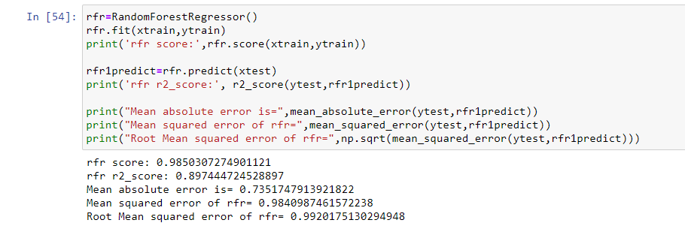
The scores from Random Forest Regressor are satisfactory as the R2 score is coming as 89.74% and RMSE value is coming as 0.99, which is the best among all the fitted models as well as the RMSE score is also low as compared to the other models.

- AdaBoost Regressor: Boosting is a algorithm that involve combining the predictions from many weak learners.
The AdaBoost(Adaptive Boosting) algorithm involves using very short (one-level) decision trees as weak learners that are added sequentially to the ensemble. Each subsequent model attempts to correct the predictions made by the model before it in the sequence. This is achieved by weighing the training dataset to put more focus on training examples on which prior models made prediction errors.
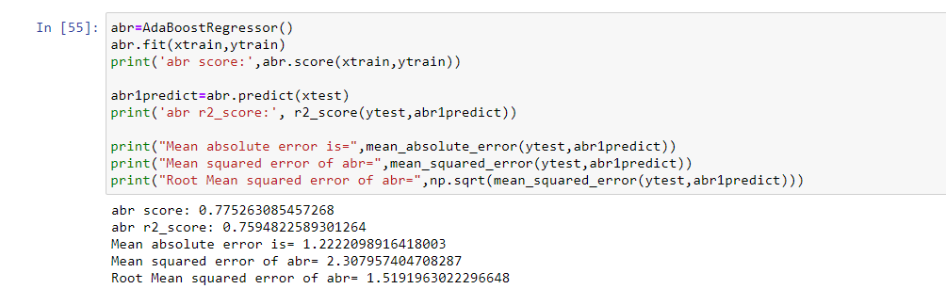
The R2 score of AdaBoost Regressor is quite low and the RMSE score is also coming as 1.5, hence moving ahead with KNeighbors regressor and Random Forest Regressor for Cross Validation and Hyper parametric Tunning.
Cross Validation
Cross-validation is a statistical method used to estimate the skill of machine learning models.
It is commonly used in applied machine learning to compare and select a model for a given predictive modeling problem because it is easy to understand, easy to implement, and results in skill estimates that generally have a lower bias than other methods.
Generally used Cross Validation method is K-Fold Cross Validation.
Moving ahead with KNeighbors regressor and Random Forest Regressor for Cross Validation as they are providing the best scores among all the fitted models.

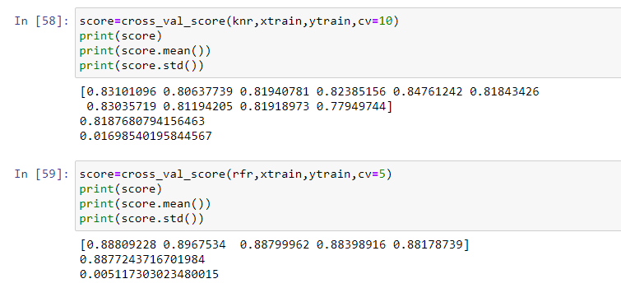
The cross validation scores are satisfactory for both the models. As the mean of cross validation score of KNeighbor Regessor is 81.87 % and the standard deviation of 0.016 and of Random Forest Regressor mean cross validation score is 88.75% and standard deviation of 0.0051.
The scores of Random Forest Regressor are good enough for keeping it as the final fitted model.
Now moving ahead with Hyper-parametric Tuning is to further improve upon the scores.

Hyper Parametric Tuning
Hyperparameter tuning is choosing a set of optimal hyperparameters for a learning algorithm. A hyperparameter is a model argument whose value is set before the learning process begins.
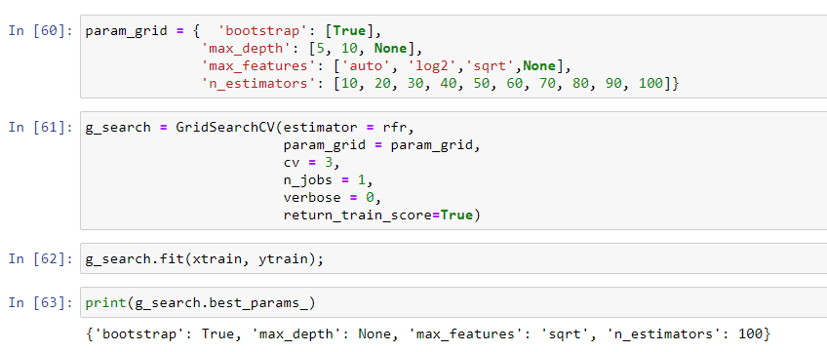
The above figure tells us the best parameters that can be used with the Random Forest Regressor to improve upon the scores in turn improving the model performance.
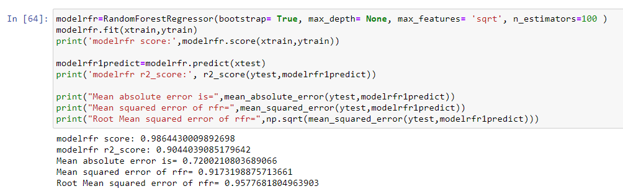
After applying the best parameters received from Hyper-parametric Tuning, the scores has improved upon and the new R2 score is coming out to be as 90.4% and the RMSE is also reduced and the value comes out to be 0.95.
Hence saving the model for further use.
Saving the Best Model
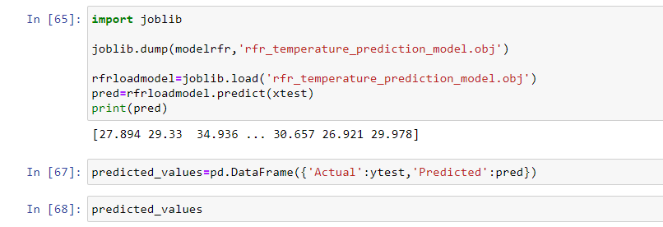
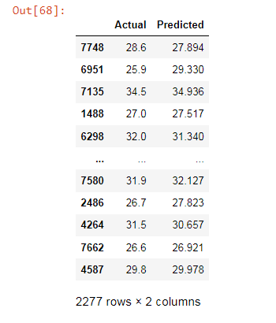
It is seen from above predicted scores that the model has performed good enough to proceed further.
Part B: Building the predictive model for minimum temperature i.e ‘Next_Tmin’.
The same set of techniques are used to develop the model for another label ie. Next_Tmin.
And the final output comes as under after applying all the steps as done under the model fitting for Next_Tmax.
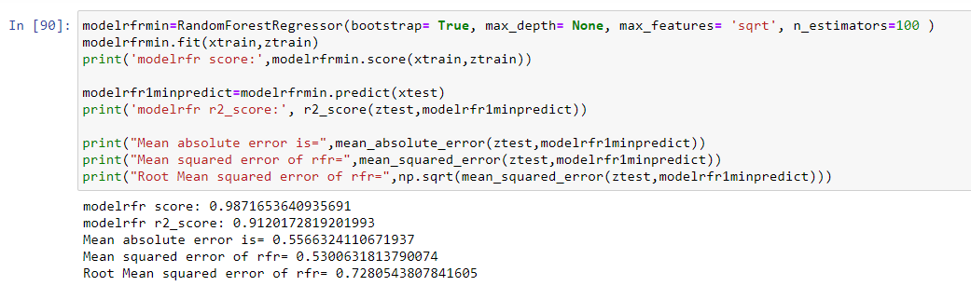
It is clear from all the fitted models, it is seen that Random Forest Regressor is the best one after Hyper-parametric Tuning. The R2 scores are coming as 91.2% and RMSE score is also low as 0.72.
Hence saving this model for further use.
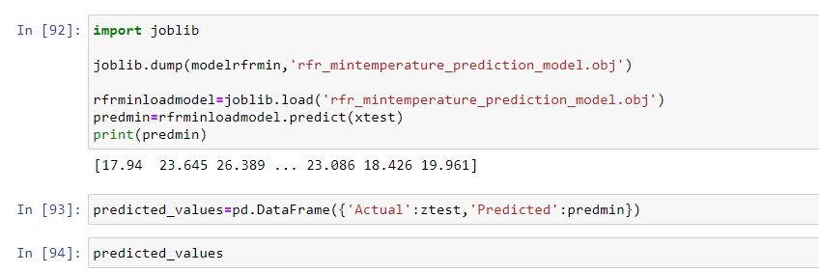
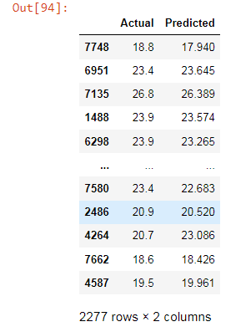
The predicted scores show that the fitted model is performing well.

Concluding Remarks
- With the help of notebook I learnt how EDA can be carried out using Pandas and other plotting libraries.
- Also I have seen making use of packages like matplotlib, plotly and seaborn to develop better insights about the data.
- I have also seen how pre-processing helps in dealing with missing values and irregularities present in the data
- The most important inference drawn from all this analysis is, I get to know what are the features on which temperature is highly positively and negatively co-related with.
- I came to know through analysis which model will work with better accuracy with the help of low RMSE scores.
- This project helped me to gain insights and how I should go with flow, which model to choose first and go step by step to attain results with good accuracy. Also get to know where to use Linear, Decision Tree and other applicable and required models to fine tune the predictions.
In the end the model predicted both the variables quite well with the prediction rate of 91% for predicting ‘what will be the temperature’? The high accuracy of the model helps prove that the given variables are highly correlated to the maximum and minimum temperature of the day. The Random Forest Regressor comes out to be the best model to predict the temperature of the next day.

